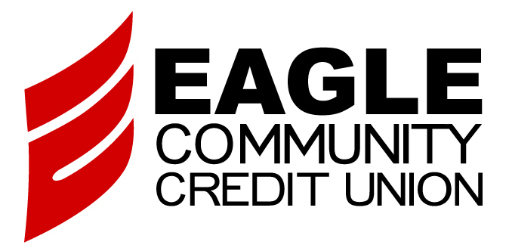
EAGLE COMMUNITY CREDIT UNION
JOINT OWNER
APPLICATION AND AGREEMENT

Primary Owner Name:

Account Number:

Joint Owner’s Social Security Number Password

1) JOINT OWNER INFORMATION AND ELIGIBILITY

Joint Owner Name First | Middle |  | Last |  |  |  |  |  | Suffix
Home Phone | Work Phone |  |  |  |  | Cell Phone
Residence Address (Street)

City |  | State |  | Zip |  |  | Email
Driver’s License Number |  | State |  | Expiration |  |  | Date of Birth
Other Identification (Type) |  |  |  |  | Number |  |  | Expiration
Occupation | Employer

ChexSystems Record? NO Unpaid Paid < 2 yrs. Paid 2 – 5 yrs. Paid > 5 yrs.
As Primary Member on Account _______________ my signature below authorizes this applicant to unlimited access to the services checked below
(Please check all that apply.)
Access Savings/Green Team/Circus Club Holiday Club _____
Checking _____ _____ _____ Other Savings _____ _____ _____
Premium Advantage MMA _____ _____ _____ ATM Card Access
Term Share Certificate(s) _____ _____ _____ Debit Card Access
I authorize you to gather whatever credit, checking account and employment information you consider appropriate from time to time. I understand that this will assist you in determining my initial and ongoing eligibility for an account. I authorize you to give information concerning your experience with me to others. USA PATRIOT Act – Customer Identification Program Notification: Federal law requires all financial institutions to obtain, verify and record information that identifies each person who opens an account, in order to help the government fight the funding of terrorism and money launderings activities. What this means for you: When you open an account, we will ask for your name, address, date of birth and other information that will allow us to identify you.
Acknowledgement of Receipt of Disclosures
By signing below, I acknowledge that I have received a copy of the Credit Union’s Disclosure and Agreement of Terms and Conditions for Eagle CU Member Accounts, Electronic Services Disclosure and Agreement, Privacy Policy and Important Privacy Choices for Consumers, and that I have received a copy of the current Rate Sheet and Service Pricing Sheet. I agree to be bound by the terms and conditions of the Credit Union’s Account Agreement(s) and any amendments thereto. I understand that any new account information will be verified.

_____________________________________ ___________________
Remember to attach a copy of the joint owner’s valid, state issued driver’s license or ID.
Primary Owner Signature Date

_____________________________________ ___________________
Joint Owner Signature Date

Eagle Community Credit Union
PO Box 5196
Lake Forest, CA 92609
(949) 588-9400 (800) EAGLE CU
www.eaglecu.org

